

Elizabeth

Woodville

School

Candidate Exam

Handbook

2025 – 2026

Roade Centre Number: 27250

Deanshanger Centre Number: 27212

Exams at EWS Academy

It is the aim of EWS Academy to make the examination experience as stress- free and successful as possible for all candidates.

This handbook is intended to inform you about examination procedures, to answer some of the most frequently asked questions and to help, guide and support candidates and parent/carer through the examination process.

Please read it carefully so that you are aware of the examination regulations and the procedures to follow in the event of any problem arising.

JCQ (Joint Council for Qualifications) sets down strict criteria which must be followed for the conduct of examinations and EWS Academy is required to follow this precisely.

This handbook should be read in conjunction with the information supplied on the EWS Academy website under the Exam Information tab:

https://www.ewsacademy.org.uk/home/exams

https://www.ewsacademy.org.uk/home/about-us/statutory-information/exam-information/

Please pay particular attention to the ‘JCQ information for candidates’ documents (social media, AI and written examinations) also the’ Warning to candidates’ and ‘Unauthorised Items Poster’ included at the back of this handbook.

If you have any queries or need help or advice at any time before, during or after the examinations please contact:

Miss Stimson (Roade) Mrs. Wallace (Deanshanger)

Email: kelly.stimson@ewsacademy.org.uk
kerry.wallace@ewsacademy.org.uk
Exams Office is based in Lower College (Roade) and Student Services (Deanshanger)

Remember – We are here to help and wish you every success in your forthcoming Exams!

Exam Timetable
This document will include a list of all the exams in the season and can be found on the school website under the Parent and Student Tabs – Exams Information.

Examination Boards
The Academy uses the following Examination Boards: AQA, Pearson, OCR and WJEC who are all regulated by JCQ.

Individual Timetable
Your individual exam timetable will be issued through your Form Tutor. Please keep it safe as you will need to refer to it daily.

This timetable will show your specific examinations with details of date, time, duration of the exam, venue, and seat number. It will also show your candidate number which is a four-digit number you will need to write on all of your exam papers. Please make sure you check this timetable before each exam, so you know your venue and seat number.

Personal Details
Please check that all your personal details are correct on your Individual Timetable. This information will appear on your certificates, so it is important it is correct. See Mrs Wallace or Miss Stimson in the Exams Office immediately if something is wrong.

Clashes
Your timetable will be carefully checked to make sure that there are no clashes. (A clash is when you have two or more exams timetabled at the same time).

Where there is a clash, the Exams Officer will re-schedule the times of the exams (on the same day). Candidates will normally sit one paper in the morning, then have a break, supervised by an Invigilator. During this time, they are not allowed to communicate with other candidates or access the internet. After the break they will be escorted to the exam venue to sit the second exam paper.

Rescheduled times will be on your individual candidate timetable. It may be necessary for you to bring a packed lunch as you will have to remain under supervision until both exams are completed.

Practical Subjects
Exam dates for Art, Photography, Food Tech and all Modern Foreign Language Speaking exams, will be agreed with your teacher and therefore will not be on your individual timetable.

Equipment you will need
Please make sure you have the correct equipment for the exam e.g.: black pens, pencils, erasers, ruler, math’s equipment, highlighter and a calculator. If you bring in a pencil case it must be a clear plastic one. Pencil cases are not allowed on the desk, unless they are clear plastic.




Calculators
Candidates may use a calculator in an examination unless prohibited by the exam board’s specification. Where the use of a calculator is allowed, candidates are responsible for making sure that their calculators meet the exam board’s regulations.
The instructions set out in this section apply to all examinations unless stated otherwise in an exam board’s specification.

Calculators must be:

of a size suitable for use on the desk; either battery or solar powered.
free of lids, cases and covers which have printed instructions or formulas.

Calculators must not:
be designed or adapted to offer any of these facilities: - language translators.
symbolic algebra manipulation; symbolic differentiation or integration.
communication with other machines or the internet.
be borrowed from another candidate during an examination for any reason; have retrievable information stored in them – this includes:
databanks; dictionaries; mathematical formulas; text

Some calculators have ‘Exam Mode’, this is acceptable if activated as the calculator then becomes compliant with the above requirements.

Where access is permitted to a calculator for part of an examination, it is acceptable for candidates to place their calculators on the floor under their desks in sight of the invigilator(s) for the non-calculator portion of the examination.

The Day of the Examination

Examination Start Times 9.00am for the morning session
1.00pm for the afternoon session (unless otherwise stated)

These are the usual start times, but candidates are responsible for checking their own timetable and arriving at school on the correct day and time, in school uniform and with the correct equipment. Candidates must arrive 15 minutes prior to the start of the examination. Please make sure you have used the toilet facilities prior to the exam.

Afternoon exams may run over the end of the normal school day, so please make sure you have arranged alternative transport home should you not be able to catch your normal school bus.

Bags are not allowed in the exam venue, so these need to be dropped off to the bag store (Roade) and the room behind reception (Deanshanger) prior to the exam.

Outside the venue, please line up and wait quietly to be called in as other exams may already be taking place.

Inside the Exam Venue
You will be under formal exam conditions from the moment you enter the exam room until you are given permission to leave by the invigilator. This means you must not talk to, attempt to communicate with or disturb other candidates once you have entered the room.

You must listen to and always follow the instructions of the invigilator in the exam room.

Find your seat quickly and quietly. You must sit in the seat indicated on your individual timetable.

Once seated check that it is your candidate card on the desk. If not please raise your hand and an invigilator will assist you.

MOBILE PHONES, EARPODS AND WATCHES MUST NOT BE BOUGHT INTO THE EXAMINATION ROOM.

If a mobile phone/smartwatch (or any other type of electronic communication or storage device) is found in your possession during an examination (even if it is turned off) it will be taken from you and a report made to the appropriate exam board. This could result in disqualification from the examination. No exceptions can be made.

Food is not allowed in the examination room. Only still water in a clear plastic bottle is allowed (any labels should be removed). Queries regarding medicines, etc, should be addressed to the Exams Officer.

At the front of the room, you will see that the centre number, name/code of the exam, day, date and time are displayed. You will need this information when you are asked to fill in the front of your exam paper.

You will be asked to check that you have the correct exam paper on your desk – check the subject and that you have the correct level i.e. Foundation or Higher. If something is wrong put your hand up and wait for an invigilator to come to you.

Listen carefully to instructions and notices read out by the Exams Officer/Invigilators –
there may be amendments to the exam paper that you need to know about.

When you are asked to do so, fill in the details on the front of your exam paper. Please use your legal name and not your preferred name. If a signature is required, please enter this.

Please make sure you put your name, centre number, candidate number and question number on any additional sheets of paper you may use.

Read all instructions on the front of the paper carefully.

Please do not open the paper before being told to do so, this is malpractice.

Please do not write on examination desks or on the desk cards. This is regarded as vandalism, and you will be asked to clean the desks or even pay for the damage.

Do not doodle on examination papers or include any offensive comments or drawings. If included the examination board can refuse to accept your paper as this is classed as malpractice.

Candidates must stay in the examination room for the duration of the exam and may not leave early. If you have finished the paper use any time remaining to check over your answers and ensure that you have completed your details correctly.

At the end of the exam all work must be handed in – remember to cross out any rough work. If you have used more than one answer book or loose sheet(s) of paper
ensure your details are written on each booklet/sheet of additional of paper.

Invigilators will collect your exam papers before you leave the room. Absolute silence must be maintained during this time. Remember you are still under exam conditions until you have left the room and should remain seated and face the front.

The Invigilator will release you a row at a time, please leave the room in silence and show consideration to other candidates who may still be working.

During the exam remember:

DO NOT talk to, attempt to communicate with or disturb any other candidate once you have entered the examination room. You must only face forward when sat at your exam desk. Turning around is malpractice.

DO NOT have anything on your desk except examination stationery and equipment needed in a clear pencil case. Any water must be in a clear plastic bottle with the label removed.

DO NOT have anything written on your hands or arms or any unauthorised notes in your pockets.

DO NOT pass anything to another candidate, including stationery.

DO NOT risk keeping your phone in your pocket or wearing a smartwatch or wristwatch. You will be subject to penalty and possible disqualification from the exam/qualification.

If you are concerned about anything, put up your hand and speak to an invigilator.

Frequently asked Questions

What to do if I am ill before the exam and unable to attend?
If you are ill before an examination and therefore unable to sit the paper, please telephone the Exams Office to inform us on 01604 862125 (Roade) or 01908 563468 (Deanshanger). It may be possible for the school to apply for special consideration on your behalf if you have supporting medical evidence.

What is Special Consideration?
Special consideration is an adjustment to the marks or grades of a candidate who is eligible for consideration. The allowance of special consideration is from 0% (consideration given but addition of marks considered inappropriate) to 5% (reserved for exceptional cases).

Candidates and Parents/carers should be aware that any adjustment is likely to be small and no feedback is ever provided. Candidates will only be eligible for special consideration if they have fully prepared and covered the whole course but performance in the examination or in the production of non-examined assessment is affected by adverse circumstances beyond their control.

Examples of such circumstances may be illness, accident or injury, bereavement, domestic crisis. The Exams Office must be informed immediately, so that necessary paperwork can be completed (within 7 days of the last exam session for each subject) and the candidate will be required to provide evidence to support such an application.

What to do if you are ill during the exam?
If you are taken ill during an exam you should put up your hand and tell an invigilator. They will then draw this to the attention of the Exams Officer.

What happens if you are late or miss an examination?
You must arrive at least 15 minutes before the start of your exam.
If you are late for any reason, please report to the Exams Officer.
The Exam Officer will escort you to the exam room and you will be given the full time allowed for your exam. If you arrive extremely late for exam (after 10am for a morning exam and after 2pm for the afternoon exam) you will sit the exam but there is a chance that the exam board will not mark your paper.

What happens if you have an unauthorised absence from an exam?
Your exams are extremely important, and it is vital that you attend all exams. If you do not turn up for an exam you will receive a zero mark, and your parent/carer/carers will be invoiced for the exam entry fee. On average, this is approximately £60 per exam but varies depending on the exam/exam board. Please advise your Head of Year/Exams Officer of any issues you have around exam time.

Can I take the exam on another day?
No. The exam timetable is published nationally by the exam boards, and you must attend on the stated date and time.

Why can’t I bring my mobile telephone/electronic devices (including watches) into the exam room?
Being in possession of a mobile phone/smartwatch/wristwatch (or any other electronic device) is regarded as malpractice and is subject to severe penalty from the exam boards.

What is meant by the term Malpractice?
Malpractice is when a candidate fails to comply with the JCQ regulations. Any alleged, suspected, or actual incidents of malpractice will be investigated and reported to the relevant exam board. To protect the integrity of the qualifications, JCQ rules and regulations must be followed.

How do I know how long the exam is?
The length of the examination is shown on your individual timetable under the heading ‘duration’. The invigilators will tell you when to start and finish your exam. They will write the start and finish times on the board at the front of the exam room. There will be a clock in all examination rooms.

What do I do if I think I have the wrong paper?
The invigilators will ask you to check before the exam starts. If you think something is wrong, put your hand up and tell the invigilator immediately.

What happens in the event of an emergency in the exam room?
In the event of an emergency, the invigilator will stop the exam and give instructions to you.

You must:
Stop writing and close your exam paper.
Stay seated until the Invigilator advises you to leave the room.
Follow your designated invigilator to the pre-arranged meeting point.

You must not:
Communicate with anyone inside and outside the exam room other than the Exams Officer and Invigilators.
Collect any personal belongings, unless advised to do so by the invigilators. If you do not follow these rules, you may not be allowed back into the exam room to complete your exam.

Supervision during your exams – Invigilators

The school employs a team of Invigilators to conduct the examinations and ensure that JCQ regulations are upheld at all times.

Candidates are expected to behave in a respectful manner towards all Invigilators and follow their instructions at all times. Any disruptive behavior, or any candidate who behaves in an unacceptable manner, will be reported to the Exams Officer.

It is the job of the Invigilator to watch candidates as they do their exams.

They will not approach you unless they think you are breaking the regulations, or you put up your hand for assistance.

The Invigilator cannot give you any help with your exam. However, if you feel there may be an error on an exam paper then please raise your hand to alert a member of the Invigilation team.

The Exams Officer and the Invigilators are also responsible for making sure your exams go as smoothly as possible and that the process if fair for everyone.

After the Examinations

Examination Results will be available to collect from School:

A Level – Thursday 13th August 2026

GCSE – Thursday 20st August 2026

If you are not able to collect your results in person you can nominate someone else to collect them on your behalf. However, you must provide them with your written permission to do so, without this we are not able to release your results, even to a parent/carer.

Any results not collected on the day will be available on Go4Schools after results collection day.

Post-result services
Enquires about results decisions are made together with subject leaders. The candidates’ consent will be required before doing so. Further details will be included in your results envelope.

Exam Certificates will be available to collect from School:

December 2026 – From Reception. The school website will be updated when certificates are ready to collect.

Again, if you are not able to collect them in person you can nominate someone else, but they must have your written permission to be able to collect them on your behalf.

Please collect your certificates as they will be needed as proof of your qualifications for future employers.

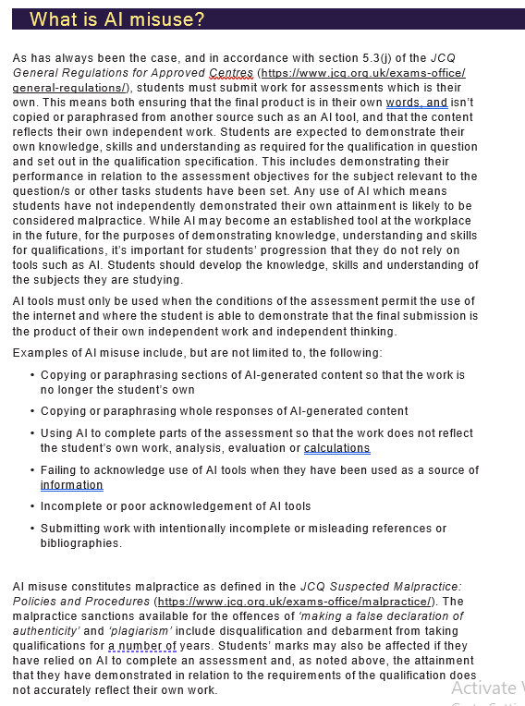
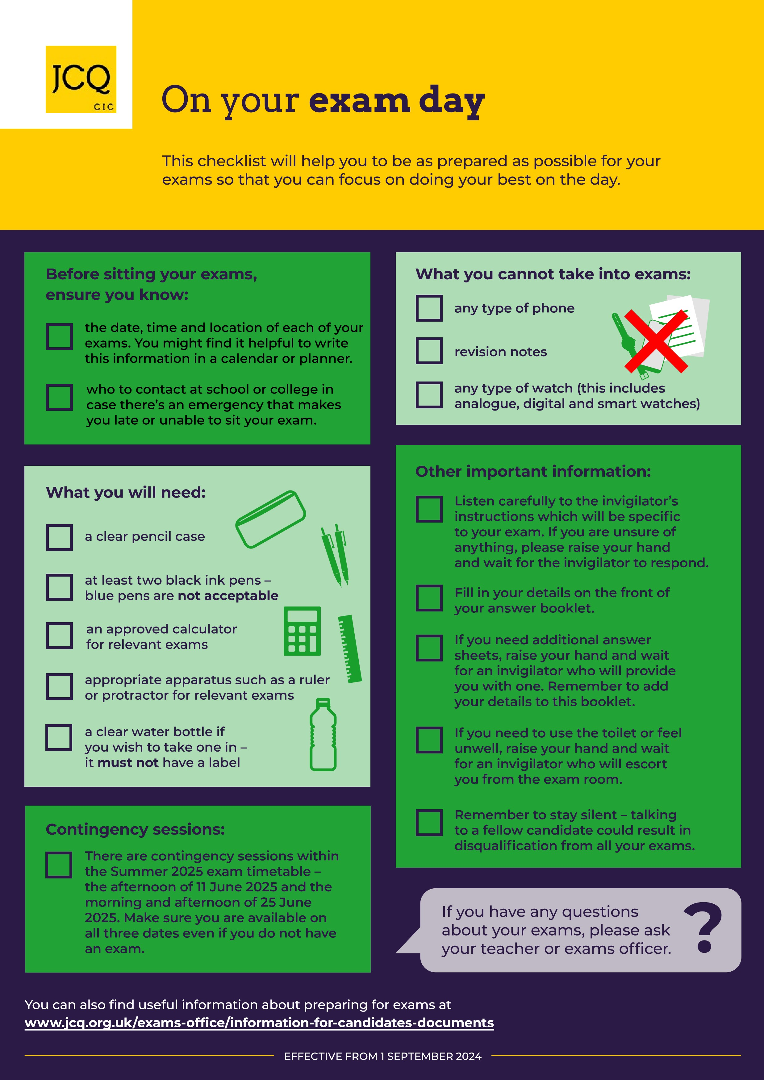

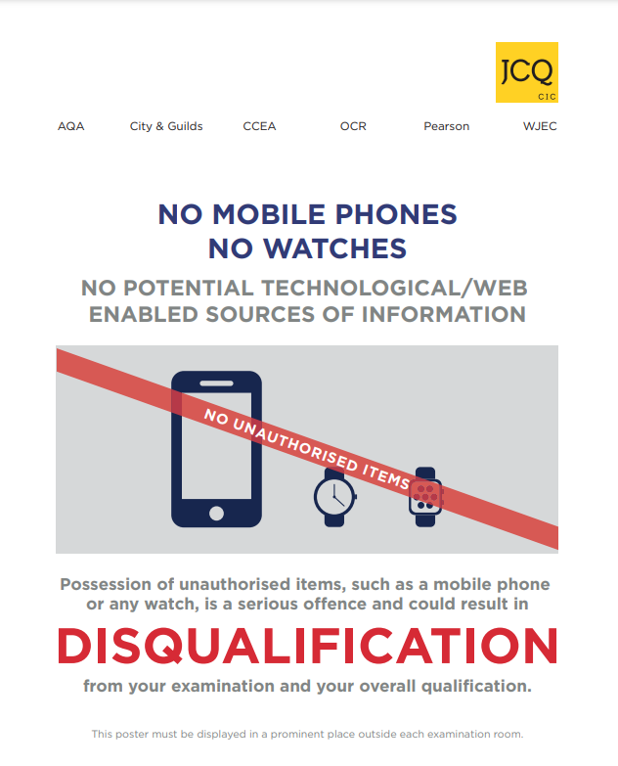



The following information needs to be read, the documents can be found at:

https://www.jcq.org.uk/exams-office/information-for-candidates-documents/

JCQ Information for candidates – Written Exams
You must read this information before you take any externally assessed timetabled written exams

JCQ Information for candidates - Coursework
You must read this information if you are undertaking qualifications that contain elements of coursework assessment.

JCQ Information for candidates – Non-Examination Assessments
You must read this information if you are undertaking qualifications that contain components of the non-examination assessment.

JCQ Information for candidates – On-Screen Tests
You must read this information if you will be taking any externally assessed on-screen tests as part of your qualification(s).

JCQ Information for candidates – Privacy Notice
You must read this notice as it contains “Information About You and How We Use It”

JCQ Information for candidates – Social Media
You must read this information to help you stay within examination/assessment regulations when using social media & AI 